**CVI620/ DPS920 Worksheet 5- Morphology and Geometric transformations**

1. Consider rotating the shown image 90 degrees counter clock wise around point (100, 100) as shown.

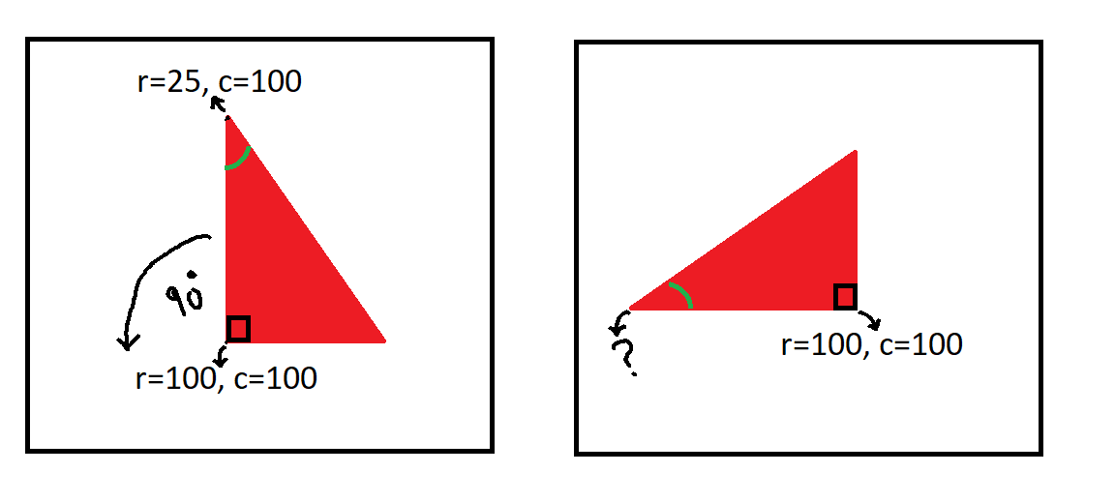

1. What is the transformation matrix?
2. What is the new coordinates of the point at row 25 and column 100 after the above rotation?

Using the coordinates as:

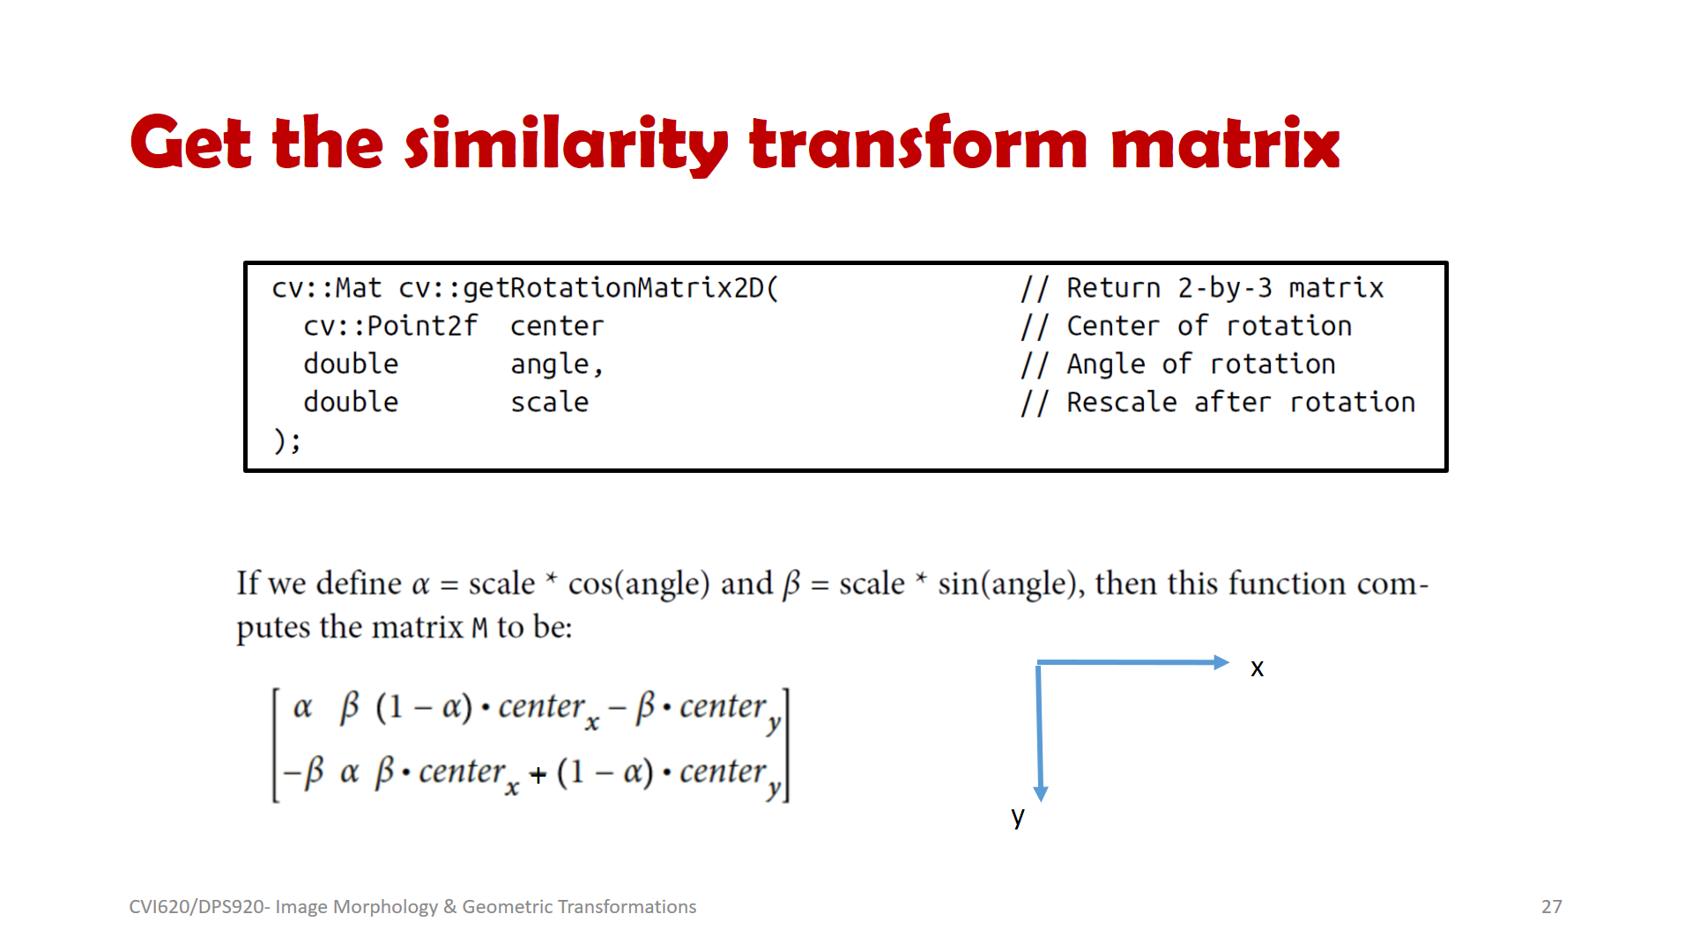

(a)

angle = 90 degrees 🡪 cos(angle) = 0, sin(angle) = 1

No change in size 🡪 scale = 1 🡪 α = 0 , β = 1

Rotation around center point (100, 100) 🡪 centerx = 100, centery = 100

$$\left(1-α\right){.center}_{x}-β{.center}_{y}=100-100=0$$

$${β.center}_{x}+\left(1-α\right){.center}_{y}=100+100=200$$

Transformation matrix: $M=\left[\begin{matrix}0 & 1 & 0 \\ -1 & 0 & 200\end{matrix}\right]$

(b)

x = c = 100, y = r = 25

$$\left[\begin{matrix}u \\ v\end{matrix}\right]=M. \left[\begin{matrix}x \\ y \\ 1\end{matrix}\right]=\left[\begin{matrix}0 & 1 & 0 \\ -1 & 0 & 200\end{matrix}\right]\left[\begin{matrix}100 \\ 25 \\ 1\end{matrix}\right]= \left[\begin{matrix}0×100+1×25+0×1 \\ -1×100+0×25+200×1\end{matrix}\right]=\left[\begin{matrix}25 \\ 100\end{matrix}\right]$$

Therefore the point will be mapped to row v=100 and column u=25.

1. Given the 10 x 10 image
2. Dilate the image using a 3 x 3 square kernel

|  |  |  |  |  |  |  |  |  |  |
| --- | --- | --- | --- | --- | --- | --- | --- | --- | --- |
| 0 | 0 | 0 | 0 | 0 | 100 | 100 | 100 | 0 | 0 |
| 0 | 128 | 128 | 128 | 0 | 100 | 100 | 100 | 0 | 0 |
| 0 | 128 | 128 | 128 | 0 | 100 | 100 | 100 | 0 | 0 |
| 0 | 128 | 128 | 128 | 200 | 200 | 200 | 200 | 200 | 200 |
| 0 | 128 | 128 | 128 | 200 | 200 | 200 | 200 | 200 | 200 |
| 0 | 128 | 128 | 128 | 200 | 200 | 200 | 200 | 200 | 200 |
| 0 | 128 | 128 | 128 | 200 | 200 | 200 | 200 | 200 | 200 |
| 0 | 128 | 128 | 128 | 0 | 0 | 0 | 0 | 0 | 0 |
| 0 | 0 | 0 | 0 | 0 | 0 | 0 | 0 | 0 | 0 |
| 0 | 0 | 0 | 0 | 0 | 0 | 0 | 0 | 0 | 0 |

1. Erode the dilated image using a 3x 3 square kernel (Close)

|  |  |  |  |  |  |  |  |  |  |
| --- | --- | --- | --- | --- | --- | --- | --- | --- | --- |
| 0 | 0 | 0 | 0 | 0 | 0 | 0 | 0 | 0 | 0 |
| 0 | 0 | 0 | 0 | 0 | 0 | 100 | 0 | 0 | 0 |
| 0 | 0 | 128 | 0 | 0 | 0 | 100 | 0 | 0 | 0 |
| 0 | 0 | 128 | 0 | 0 | 0 | 100 | 0 | 0 | 0 |
| 0 | 0 | 128 | 128 | 128 | 200 | 200 | 200 | 200 | 0 |
| 0 | 0 | 128 | 128 | 128 | 200 | 200 | 200 | 200 | 0 |
| 0 | 0 | 128 | 0 | 0 | 0 | 0 | 0 | 0 | 0 |
| 0 | 0 | 0 | 0 | 0 | 0 | 0 | 0 | 0 | 0 |
| 0 | 0 | 0 | 0 | 0 | 0 | 0 | 0 | 0 | 0 |
| 0 | 0 | 0 | 0 | 0 | 0 | 0 | 0 | 0 | 0 |